Please find the link attached for notebook view:

https://drive.google.com/file/d/1q6LOHnv8bv_BOHK8ccmW9ZBLFLuQSTYE/view?usp=sharing

Business Insights based on Non- Graphical and Visual Analysis

Comments on the range of attributes
1.
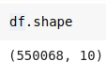
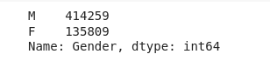

2.
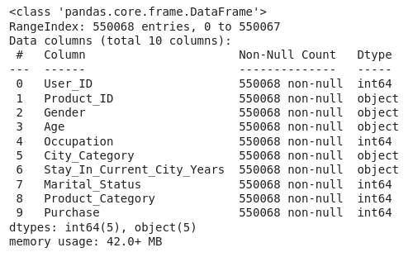

3.
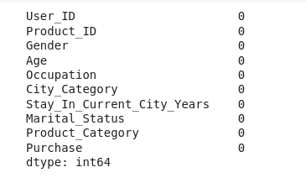

Comments on the distribution of the variables and relationship between them
Insights:
--> looks like most of our purchases lie in range 5000 to 9000.
-->Number of products bought by mail is more than female.
-->Customers from age group 26-35 bought more products as compare to any other category.

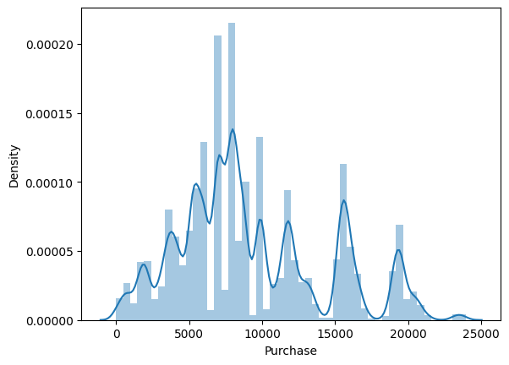
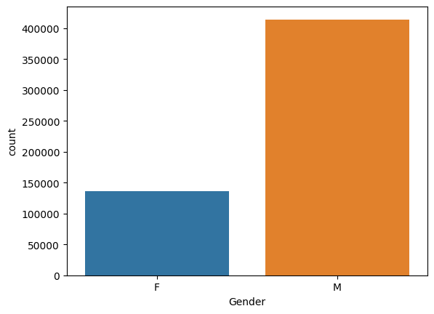

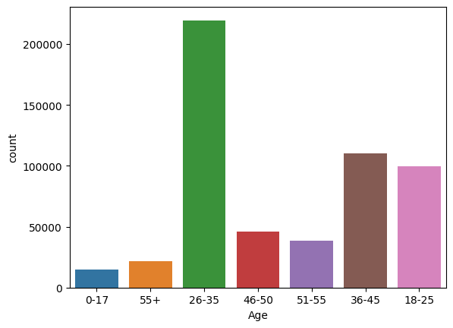

Comments for each univariate and bivariate plot
Insights:

--> Doesn’t look much difference in male and female purchase amount, a little upper value for male on purchase but doesn’t signifies much.
--> For product id 14 and 15 Female tends to buys more as compare to mens. So we specifically focuses on those 2 categories for females.

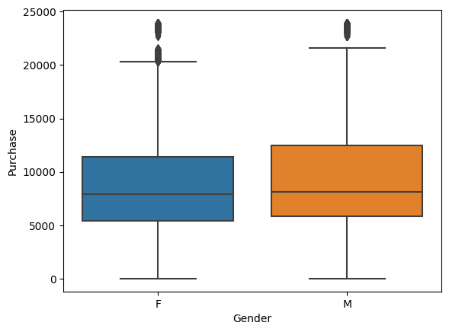
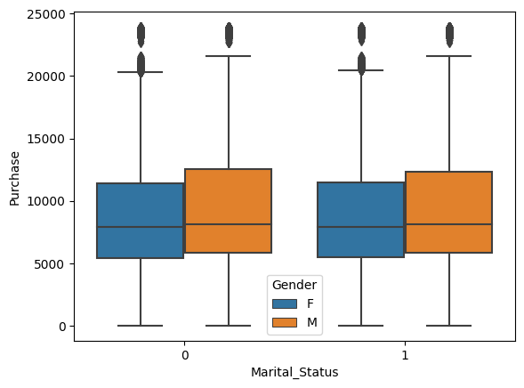

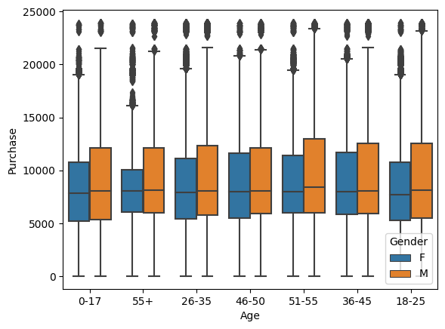

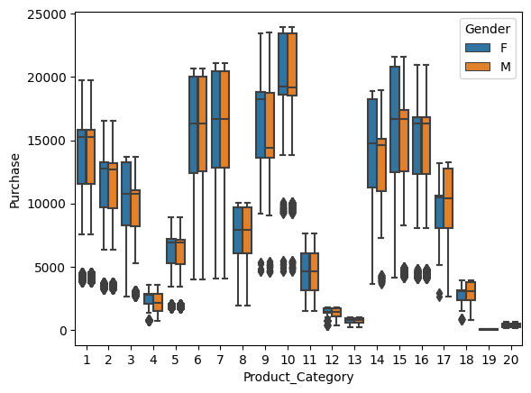

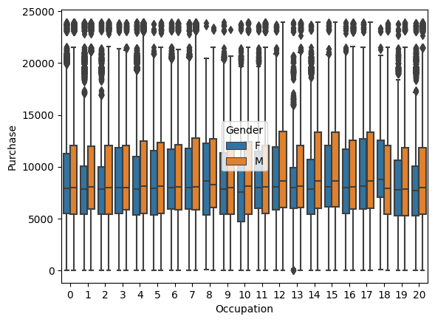

1. Are women spending more money per transaction than men? Why or Why not?

Insights:
--> there is not clear evidence that women spending more than men as per data we received.

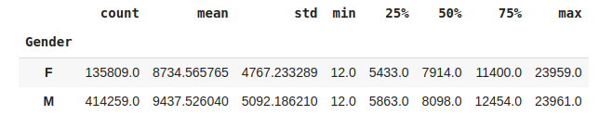

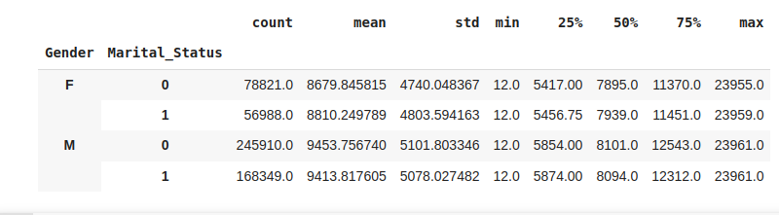

2. Confidence intervals and distribution of the mean of the expenses by female and male customers

Insights:
-With sample size of 5000, it clearly indicates that male spends more while purchasing as compare to females.

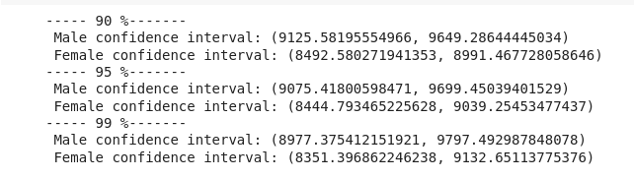

3. Are confidence intervals of average male and female spending overlapping? How can Walmart leverage this conclusion to make changes or improvements?

Insights:
As per the results received if we fetch the confidence intervals of male and female, then they don’t overlap and states that there is difference in spends by male and female.

4. Results when the same activity is performed for Married vs Unmarried.

Insights:
Looks like an overlapping in Single Vs Married, hence there is no suffiecient proof to say that there is any purchase disparity.

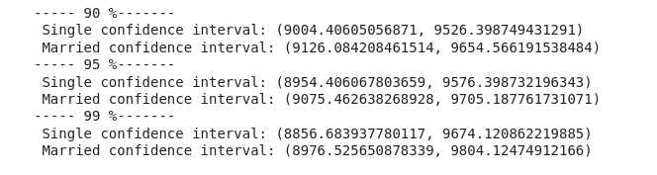

5. Results when the same activity is performed for Age.

Insights:
--> when we take a little close look, there is a difference between 51-55 Vs (0-17, 26-35) and also 36-45 Vs 26-35 spend pattern with 90% significance value.
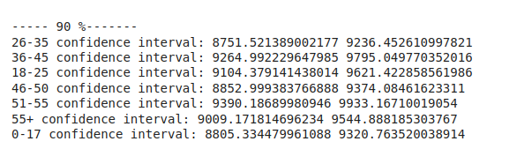

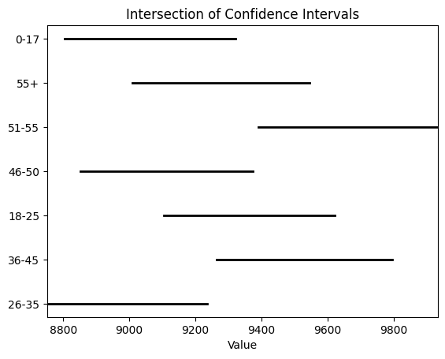

Insights:
--> with 95% significance value there is a different in purchasing pattern between age group 26-35 Vs 51-55
--> with 99% significance value no purchase dispairity seen.
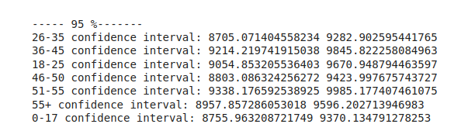
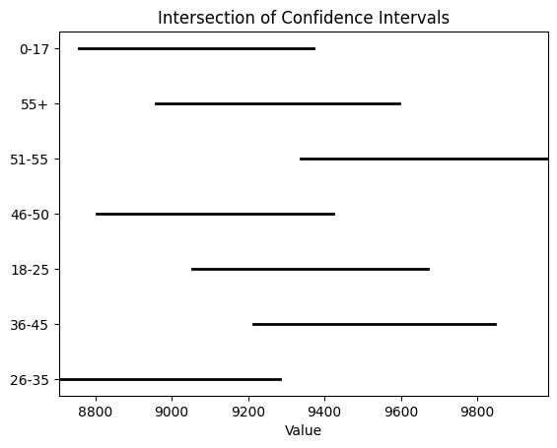

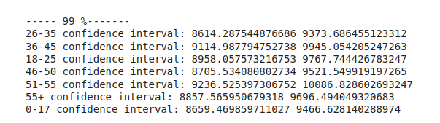

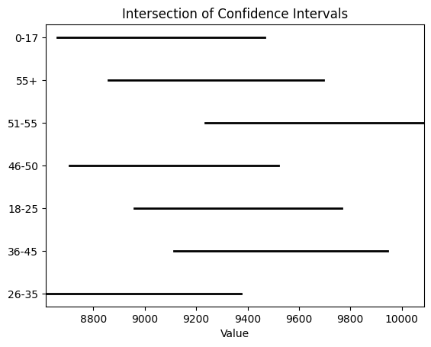

Recommendations
  - Actionable items for business. No technical jargon. No complications. Simple action items that everyone can understand

1. Purchase Trends:

a. There is difference in purchase between male and female, male tends to have more purchase value as compare to females. We have to do market analysis and focus more on products that females tends to buys so that we can improve our female purchase as well.

b. No difference based on Marital Status, that means our bussiness is unbiased and no impact on marital status of our customers

c. No difference or disparity in purchase with different age group, which is positive for our bussiness. We are catering to all king of generations and keep focusing on building our bussiness for all generations.
But yes few of the age groups have purchase disparity which we have to understand and make our inventory available for that age group as well especifically for age group 26-35.

3. For few of the product categories attached below, we see females tends to buy more which give us an important input on their liking. We should keep focusing on such kind of item and make our inventory more strong to improve female interection with our brand.

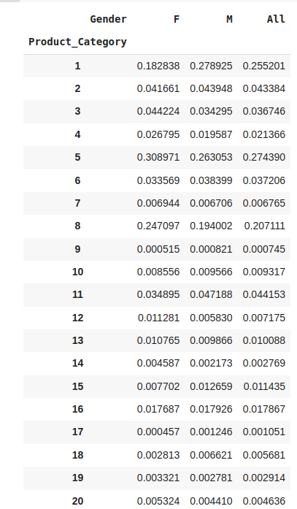

4. Our main purchase sales ranges from 6000-9000, we have to make sure to cater this range of product to our users and keep the inventory in good shape for the given range.

END

